**Smart**

**farm**

**ing**

**-**

**IoT**

**Enabled**

**Smart**

**Farming**

**Application**

**SOLUTION ARCHITECTURE**

Date

20

-

10

-

2022

Project

Name

Smart

far

ming

-

IoT

Enabled

Smart

Farming

Application

Maximum

Marks

4

Marks

**Solution**

**Architecture**

**Diagram:**

Team Leader:

S.RESHMA

Team

members:

M.ARUN,E.NAVEEN,

M.KARTHIK

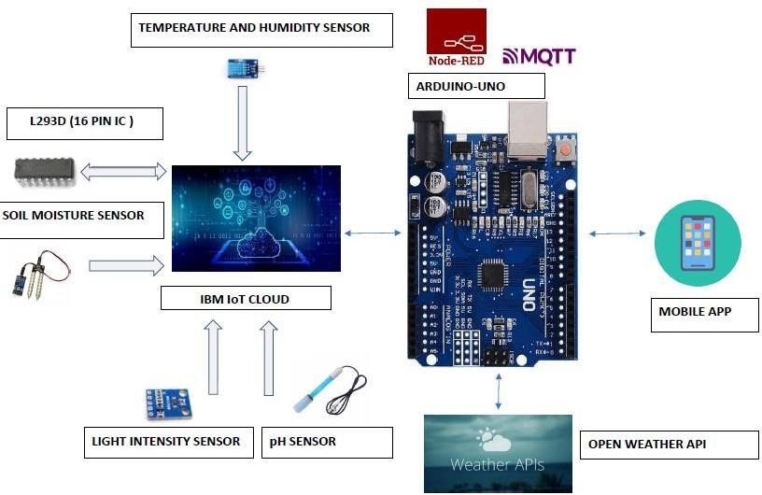

|  |
| --- |
| * The different soil parameters (temperature, humidity, light intensity, pH level) are sensed using different sensors and the obtained value is stored in IBM cloud.      * The L293D is a 16-pin Motor Driver IC which can control a set of two DC motors simultaneously in any direction. The L293D is designed to provide bidirectional drive currents of up to 600 mA (per channel) at voltages from 4.5 V to 36 V (at pin 8!).      * Arduino UNO is used as a processing unit which processes the data obtained from sensors and weather data from weather API.      * Node-RED is a programming tool for wiring together hardware devices, APIs and online services in new and interesting ways. It provides a browser-based editor. * The MQTT protocol is followed for communication.      * All the collected data are provided to the user through a mobile application which was developed using MIT app inventor.      * Open Weather provides hyperlocal minute forecast, historical data, current state and from short-term to annual and forecasted weather data. All data is available via industry standard APIs.      * The user could make decision through an app, whether to water the crop or not, depending upon the sensor values. |